HS/TE14/0046
S.T.A.Wickramasinghe
Lesson Plan
Unit - Unit 10
Future
Lesson focus - Future Continuous Tense
Grade - Grade 7
Time allocated - 40 minutes
Class profile - 18 ESL students (12 male and 6 female) JMC International
College.
Main aims - To comprehend the correct usage of future continuous tense.
- To expand grammatical competence of the students.
Subsidiary aims - Identify sentences in future continuous tense.
- Construct meaningful sentences using future continuous tense.
Assumptions - Students will be able to use future continuous tense
sentences meaningfully and accurately.
Anticipated problems - Students may not know the continuous form of the verb.
Possible solution - Explaining the continuous form where necessary.
Materials needed - Pupil's book
Whiteboard
Skills focused - Writing, Speaking, Reading
Rationale -The purpose of selecting this lesson is to encourage students to
construct sentences using future continuous tense and to
express their ideas in future continuous tense.
Procedure

Time | Stage aim | Teacher role |  |  |  | Student role | Materials needed |  |  | Interaction pattern
Pre Task

10 minutes | To express sentences in future tense using real life situations. |  | Teacher asks students about their plans for tomorrow and next week. Then the teacher will repeat their future tense sentences and writes the sentences in future continuous tense on the board. |  |  | Speaking  Students describe their plans in future tense. | Whiteboard |  |  | Whole class activity
While Task

20 minutes | Building up sentences using future continuous tense sentences. |  | Teacher explains the characteristics of a future continuous tense sentence and writes examples on the board explaining the rules. |  |  | Listening, Speaking  Students listen attentively and give examples of future continuous tense sentences. |  | Whiteboard | Whole class activity
Post Task

10 minutes | Building up sentences using simple future continuous tense sentences. |  |  | Teacher asks the students to do the Activity 13 (Appendix 1) | Reading, Writing  Students complete the activity 13. |  | Pupil's book  Writing book |  |  | Individual activity

Take home assignment –
Teacher asks the students to complete Activity 12 of the Pupil's book (Appendix 2)

Appendix
Appendix 1
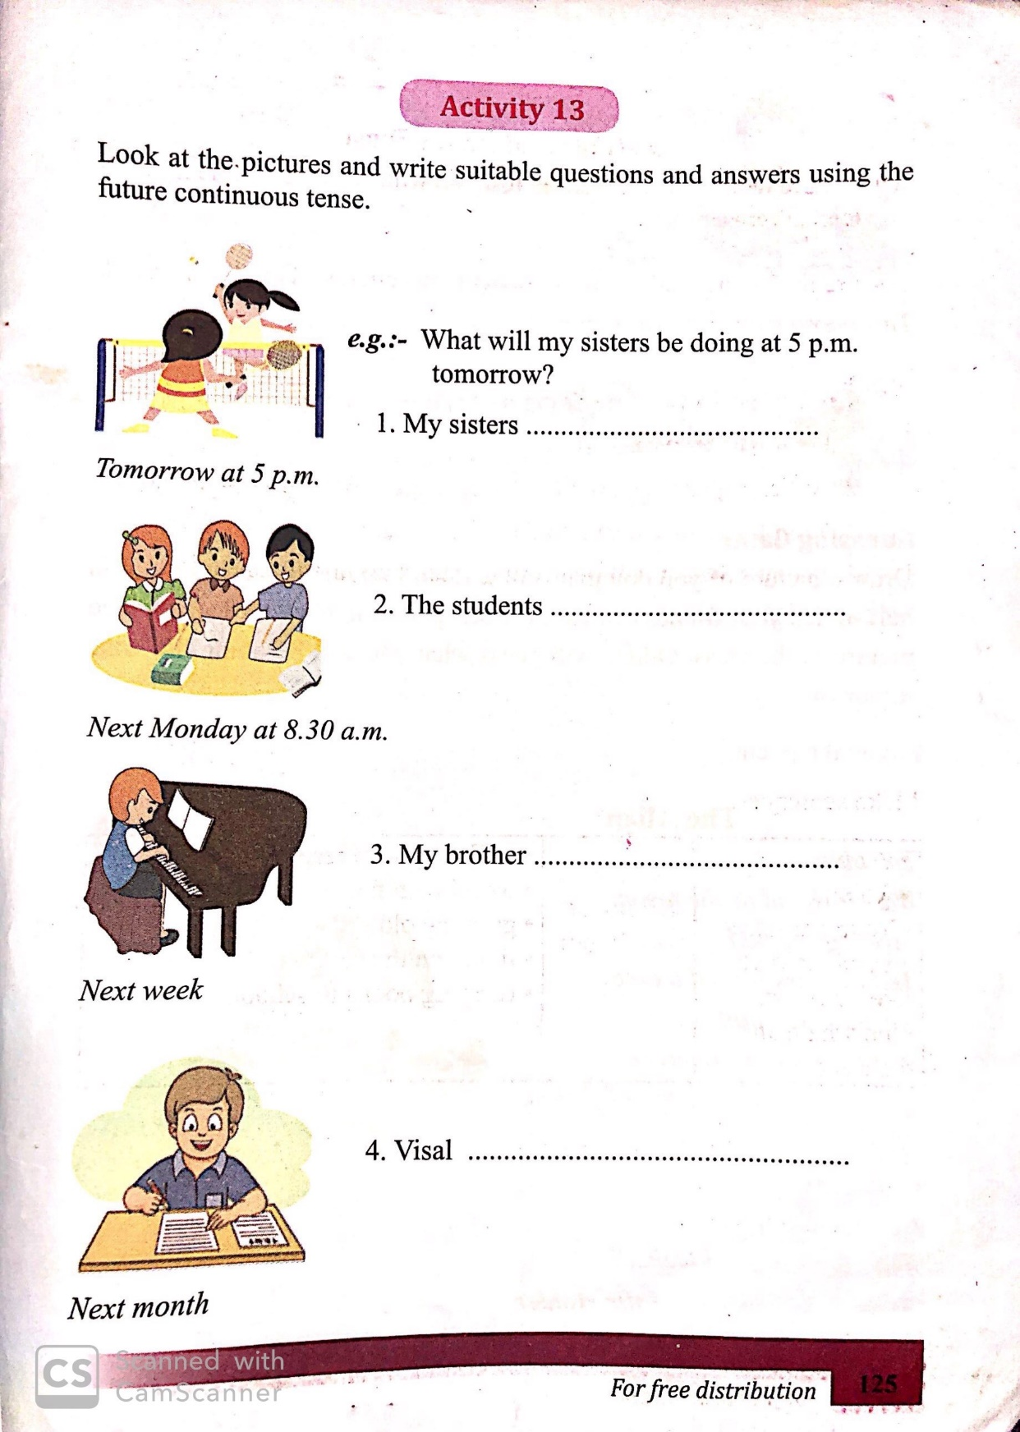
Appendix 2
