HS/TE14/0046 - S.T.A.Wickramasinghe
Lesson Plan – Future
Unit - Unit 13 - Future
Grade - Grade 10
Time allocated - 40 minutes
Class profile - 18 ESL students (12 male and 6 female) JMC International
College.
Main aims - Extract specific information from the given passage.
- Transfer the given information in a text to a table.
Subsidiary aims - To gather information using WH questions
- To recognize the general idea of a text.
- Enhancing vocabulary.
Assumptions - Students will be able to extract specific information from the
passage and transfer the information into a table.
Anticipated problems - Students may have difficulty in determining the meaning of
some words and phrases.
Possible solution - Explaining difficult words, phrases and new vocabulary
given in the text using simple language before starting the
activity.
Materials needed - Exercise book
Pupil's book
Whiteboard
Skills focused - Reading, Writing, Speaking
Rationale -The purpose of selecting this lesson is to enable the students to
extract the information in a text and transfer the needed
information into other forms.
Procedure –

Time | Stage aim | Teacher role |  |  | Student role |  |  | Materials needed |  | Interaction pattern
Pre Task

10 minutes | To gather information by asking questions. |  | Teacher asks the students about the importance of electricity in day today life and the importance of saving electricity. Teacher writes down the given answers on the board. |  | Speaking  Students give different answers |  |  | Whiteboard |  | Whole class activity
While Task

15 minutes | Extract specific information from the given passage. |  | Teacher asks all students to read the passage (Appendix 1) together. Teacher discusses about the ‘Earth Hour’ with students. Teacher writes and explains the difficult words and phrases. |  |  | Reading, Speaking  The students read the passage and discuss with the teacher and get the help of the teacher where necessary. | Pupil's book  Whiteboard |  | Whole class activity
Post Task

15 minutes | To extract information from the given text.  To transfer the needed information into a table.  . |  |  | Teacher asks the students to complete Activity 01 (Appendix 2), Activity 02 (Appendix 3) and provides feedback. |  | Reading,Writing  Students complete Activity 01 and 02. |  | Exercise book |  | Individual activity
Take home assignment –

Teacher asks the students to complete Activity 03. (Appendix 4)

Appendix

Appendix 1

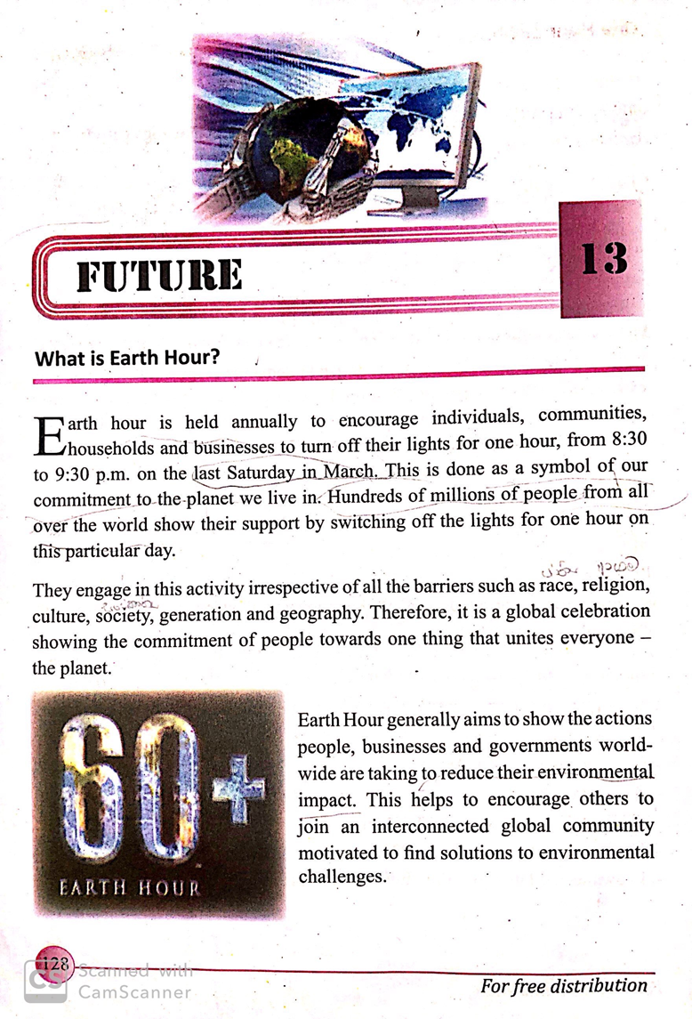

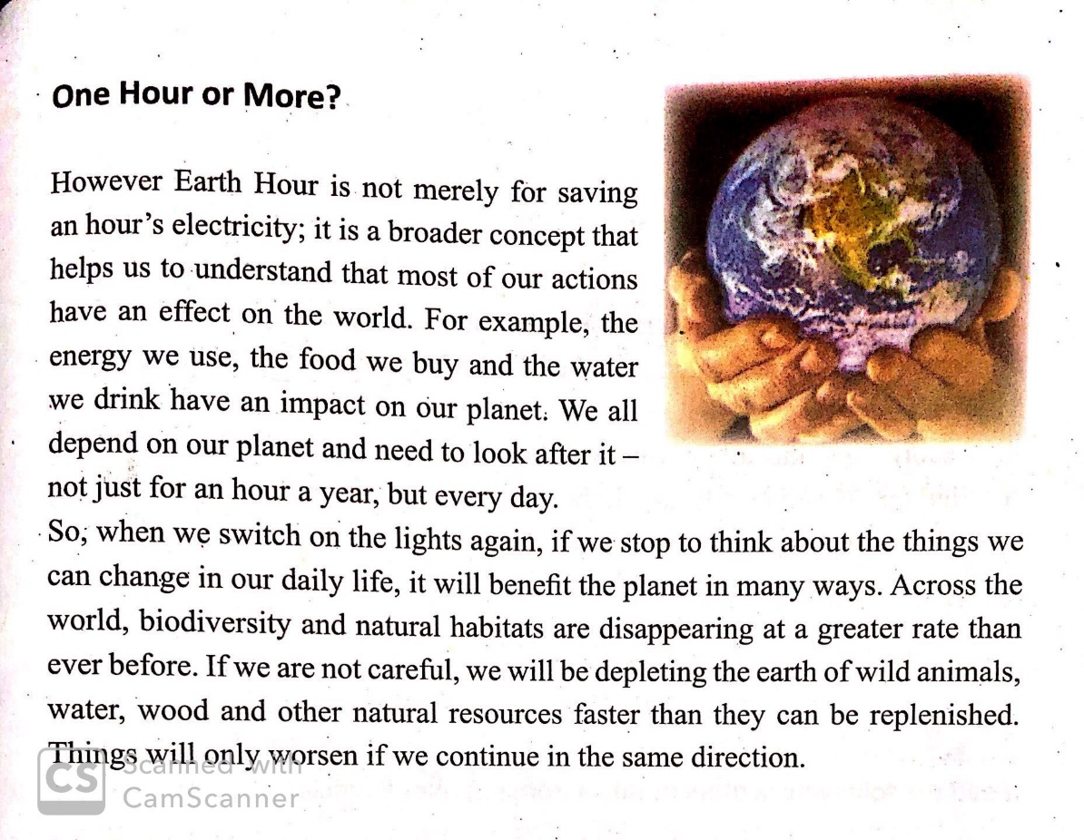

Appendix 2

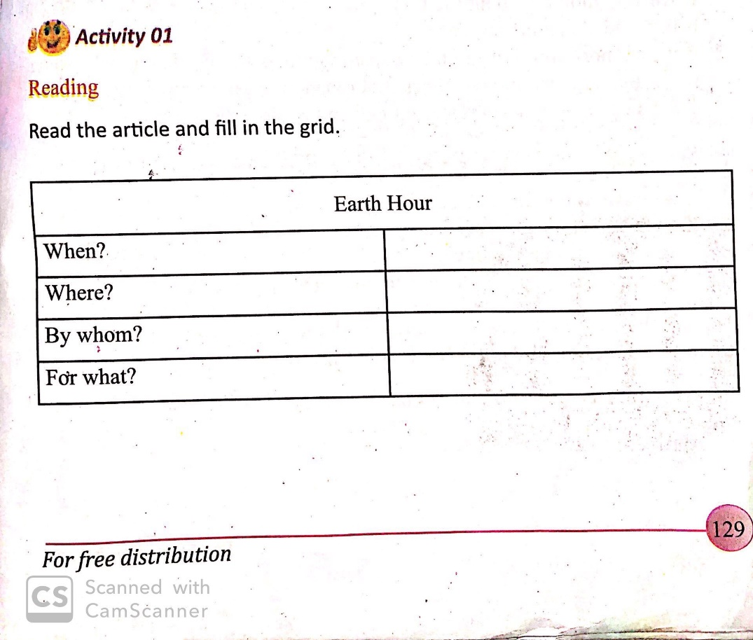
Appendix 3

