HS/TE14/0046
S.T.A.Wickramasinghe
Lesson Plan
Unit - Unit 9
Our Beautiful World
Grade - Grade 07
Time allocated - 40 minutes
Class profile - 18 ESL students (12 male and 6 female) JMC International
College.
Main aims - To understand poetic language, techniques, structure and
message given.
. - To appreciate the beauty of the language and the thought in
the poem.
- To kindle the students' imagination and develop their
aesthetic sense.
Subsidiary aims - To be able to express students’ ideas, feelings, emotions.
- To identify rhyming aesthetic sense.
Assumptions - Students will be able to comprehend the poem through
poetic language.
Anticipated problems - Students may have difficulty in understanding poetic
language.
Possible solution -Explaining the poetic language and meaning relevant to the
poem and writing them on the board.
Materials needed - Pupil's book
Whiteboard
Skills focused - Writing, Speaking, Reading, Listening
Rationale -The purpose of selecting this lesson is to improve students'
imagination and develop their aesthetic sense.

Procedure

Time | Stage aim | Teacher role |  |  | Student role |  | Materials needed |  | Interaction pattern
Pre Task

10 minutes | To build a general conversation on things students experience that give a feeling of curiosity to them. |  | Teacher asks the students to express their experiences with nature relating to incidents that made them curious about and writes them on the board. |  | Speaking  Students express their experiences. |  | Whiteboard |  | Whole class activity
While Task

20 minutes | To comprehend the poem through poetic language and to develop the students’ aesthetic sense. |  | Teacher asks the students to recite each stanza of the poem (Appendix 1) in groups. Teacher asks the students to discuss in groups what they feel about the poem. Teacher explains the poem along with rhyming words, difficult words and phrases and discusses the poetic language and the techniques used in this poem. |  | Speaking, Listening  Students discuss with the group members. | Pupil’s book |  | Group activity
Post Task

10 minutes | To evaluate if the students have grasped the poem. | Teacher asks the students to complete Activity 18. (Appendix 2)  Teacher discusses the answers and gives feedback. |  | Reading, Writing  Students complete the given activity. |  |  | Exercise book |  | Individual activity

Take home assignment –
Teacher asks the students to build a simple poem related to beauty of nature.

Appendix
Appendix 1
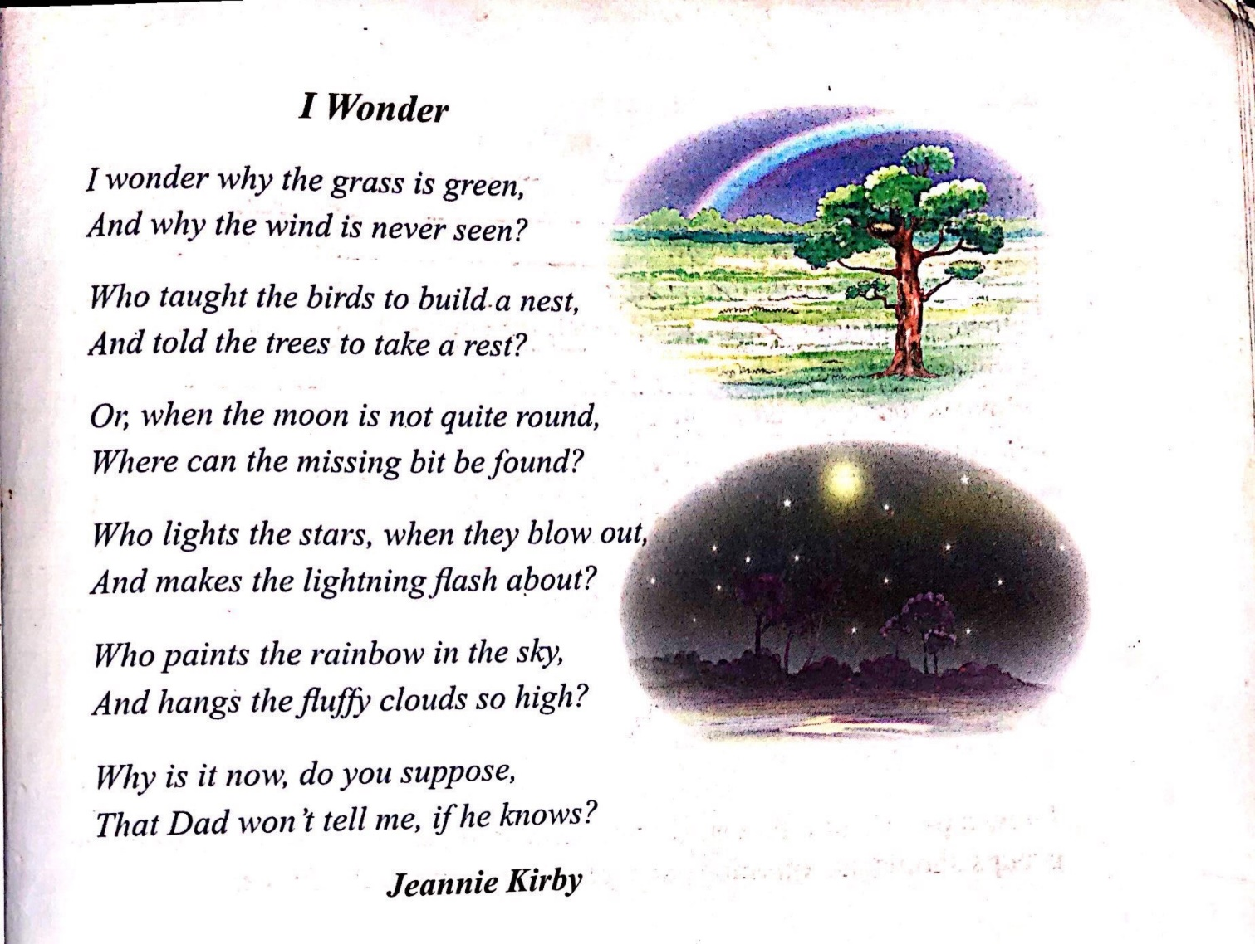

Appendix 2
