HS/TE14/0046
S.T.A.Wickramasinghe
Lesson Plan
Unit - Unit 8
Wonders Around Us
Grade - Grade 07
Time allocated - 40 minutes
Class profile - 18 ESL students (12 male and 6 female) JMC International
College.
Main aims - Extract specific information from the given passage.
- Transfer the given information in a text to a table.
Subsidiary aims - Recognizing the general idea of a text.
- Enhancing vocabulary.
- Using both context and picture clues to determine the
meaning of new words.
Assumptions - Students will be able to extract
specific information from the passage and transfer the
information into a table.
Anticipated problems - Students may have difficulty in determining the meaning of
some words and phrases as well as in pronunciation.
Possible solution -Explaining difficult words, phrases and new vocabulary
relevant in simple language and pronouncing them and writing
them on the board.
Materials needed - Laptop
Pupil’s text
Whiteboard
Skills focused - Reading, Writing, Speaking
Rationale -The purpose of selecting this lesson is to enhance the students’
knowledge on the new wonders of the world.
Procedure

Time | Stage aim | Teacher role |  |  | Student role |  | Materials needed |  | Interaction pattern
Pre Task

10 minutes | Expressing students’ ideas about the wonders of the world. |  | Teacher asks the students to tell what they know about the wonders of the world and writes them on the board. Then teacher shows a 2 minute video clip (Appendix 1) on the new seven wonders of the world. |  | Speaking  Students describe the wonders of the world. |  | Whiteboard  Laptop |  | Whole class activity
While Task

25 minutes | Students will be able to Students will be able to extract specific information from the passage. |  | Teacher asks the students to read the passage (Appendix 2) together and teacher discusses the difficult words and phrases writing them on the board. Teacher asks the students to do an activity (Activity 4) (Appendix 3) based on WH questions. Teacher discusses answers and provides feedback. |  | Reading,Writing  Students complete the activity. | Exercise book |  | Individual activity
Post Task

5 minutes | Transfer the given information in a text to a table. | Teacher divides the class into pairs and ask the students to complete the given table in Activity 3 (Appendix 4) Teacher discusses answers and gives feedback. |  | Reading, Writing  Students will complete the given activity. |  |  | Exercise book |  | Pair activity

Take home assignment –
Teacher asks the students to complete Activity 5 of the Pupil's book (Appendix 5)

Appendix
Appendix 1
https://www.youtube.com/watch?v=CpqzljqSBgc

Appendix 2
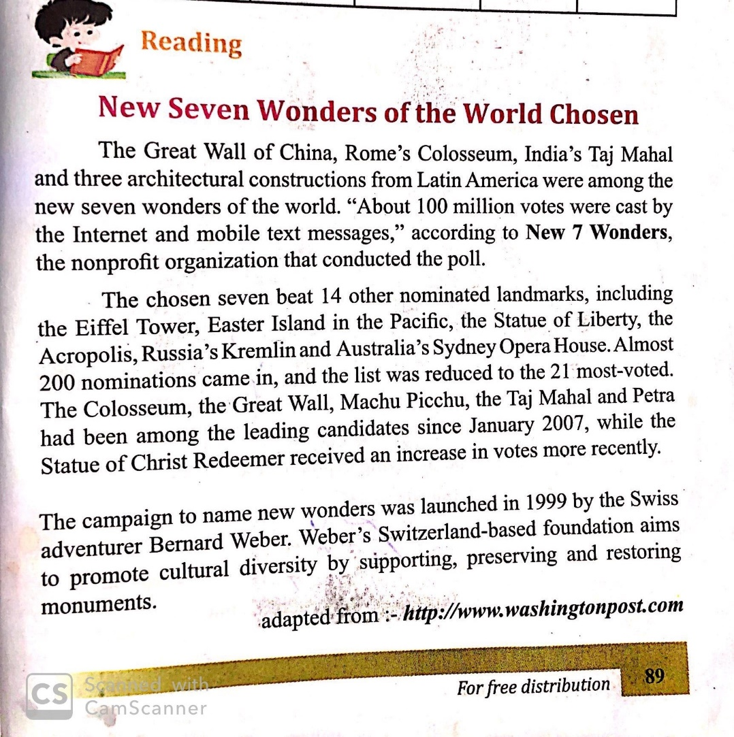

Appendix 3
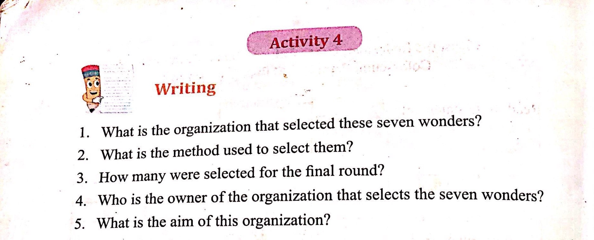
Appendix 4
