HS/TE14/0046
S.T.A.Wickramasinghe
Lesson Plan
Unit - Unit 8
It's a Small World
Lesson focus - Passive Voice – Simple Future Tense
Grade - Grade 8
Time allocated - 40 minutes
Class profile - 15 ESL students (11 male and 4 female) JMC International
College.
Main aims - Identify passive voice sentences in future tense.
. - Construct sentences using passive voice future tense.
Subsidiary aims - Turn an active voice future tense sentence to passive voice.
- Turn a passive voice future tense sentence to active voice.
Assumptions - Students will be able to use passive voice future tense
sentences correctly.
Anticipated problems - Students may not know the past participle of the verb.
Possible solution - Explaining the past participles where necessary.
Materials needed - Pupil's book
Whiteboard
Skills focused - Writing, Speaking, Reading, Listening
Rationale -The purpose of selecting this lesson is to encourage students to
construct sentences using passive voice future tense and to
express their ideas in future tense.
Procedure

Time | Stage aim | Teacher role |  |  |  | Student role | Materials needed |  |  | Interaction pattern
Pre Task

10 minutes | To express sentences in future tense using real life situations. |  | Teacher asks about the upcoming school annual concert from the students. Once the students describe the events in future tense and teacher writes them on the board. |  |  | Speaking  Students describe the events and performances happening at the concert in future tense. | Whiteboard |  |  | Whole class activity
While Task

20 minutes | Building up sentences using simple future tense passive voice sentences. |  | Teacher explains the characteristics of a simple future tense passive voice sentence and demonstrates how an active voice future tense sentence changes into a passive voice sentence with examples writing them on the board. |  |  | Listening, Speaking  Students listen attentively and give examples of simple future tense passive voice sentences. |  | Whiteboard | Whole class activity
Post Task

10 minutes | Building up sentences using simple future tense passive voice sentences. |  |  | Teacher asks the students to do the Activity 8.3 (Appendix 1) and 8.4 (Appendix 2) in the pupil's book and provides feedback. | Reading, Writing  Students complete the activity 8.3 and 8.4. |  | Pupil's book  Writing book |  |  | Individual activity

Take home assignment –
Teacher asks the students to complete Activity 8.5 of the Pupil's book (Appendix 3)

Appendix

Appendix 1
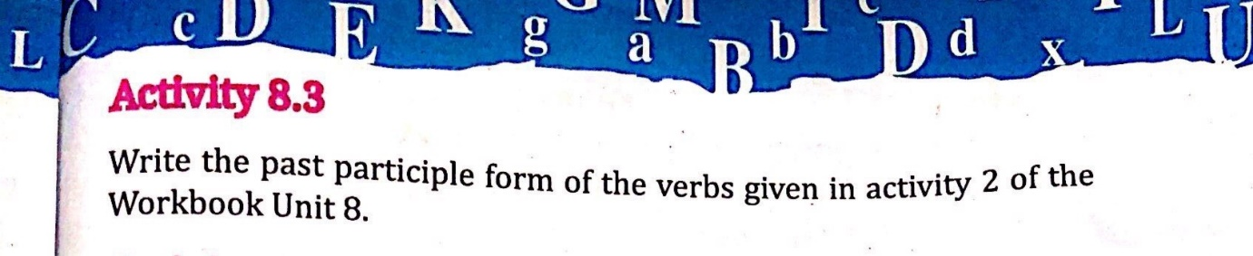
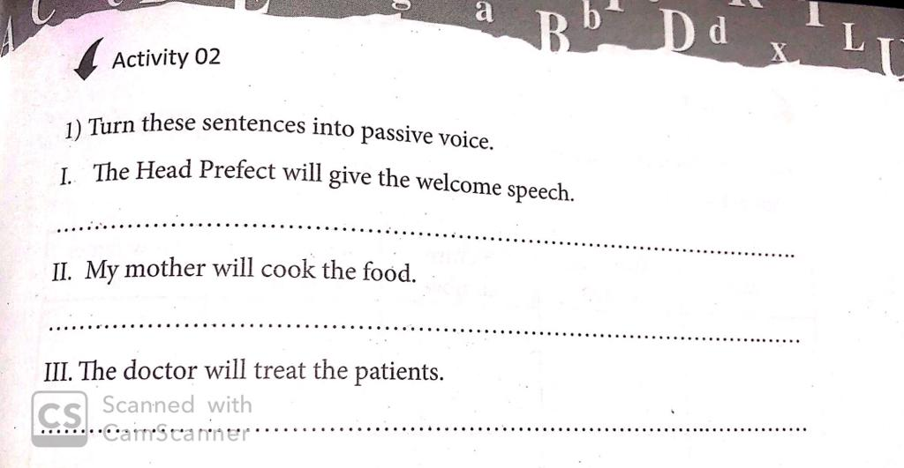

Appendix 2
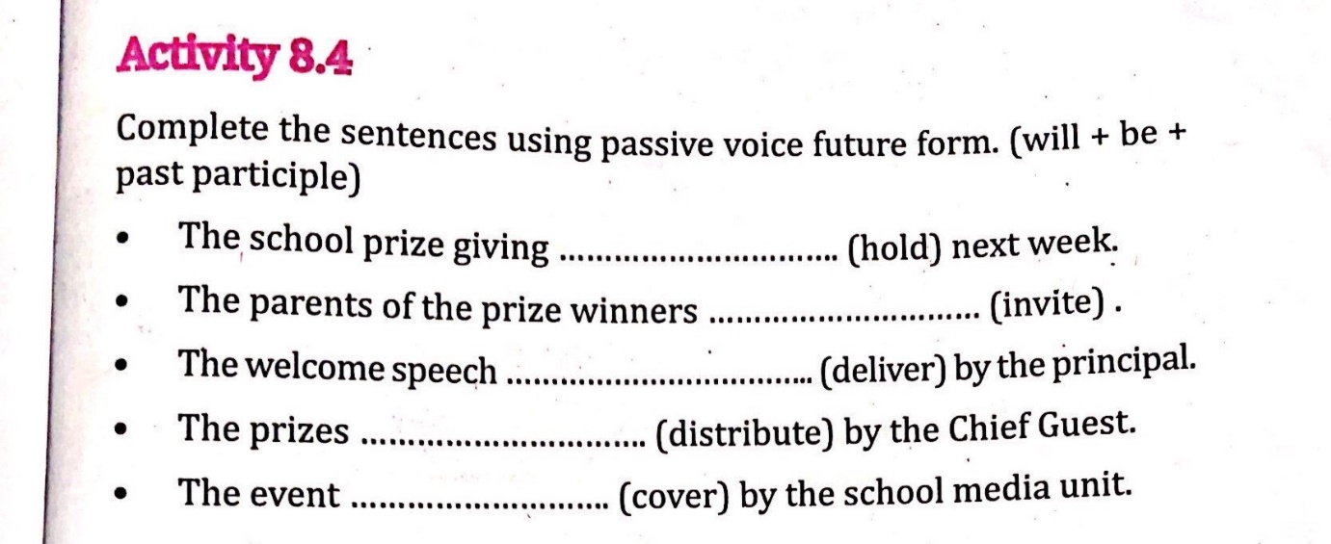

Appendix 3
