HS/TE14/0046
S.T.A.Wickramasinghe
Lesson Plan - Observation 01
Unit - Unit 7
The World of Children
Grade - Grade 08
Time allocated - 45 minutes
Class profile - 15 ESL students (11 male and 4 female) JMC International
College.
Main aims - Encouraging the use of English creatively and innovatively in
writing.
. - Writing a story based on pictures.
Subsidiary aims - Forming correct sentences with relevant words.
- Improving vocabulary relevant to the text.
- Creating a suitable title to the story.
- Increasing children's willingness to communicate thoughts
and feelings with peers.
Assumptions - Students will be able to write simple stories creatively.
Anticipated problems - Students may have difficulty in finding the exact and relevant
vocabulary.
Possible solution -Explaining difficult words, phrases and new vocabulary relevant to the story and writing them on the board before writing the story.
Materials needed - A4 papers
Coloured sets of pictures
Pupil's book
Whiteboard
Skills focused - Writing, Speaking, Reading, Listening
Rationale -The purpose of selecting this lesson is to improve students' creativity and to enhance their vocabulary.
Procedure

Time | Stage aim | Teacher role |  |  | Student role |  | Materials needed |  | Interaction pattern
Pre Task

10 minutes | Discussing the vocabulary and phrases relevant to the story. |  | Teacher divides the class into five groups and distributes a set of six pictures (Appendix 1) to each group. Then the teacher asks the students to look at the pictures and describe what they see. The teacher writes them on the board explaining new and difficult vocabulary. |  | Speaking  Students describe what they see in the pictures. |  | Sets of coloured pictures |  | Whole class activity
While Task

25 minutes | Building up a story through pictures. |  | Teacher asks the students to discuss with the group members and to build up a creative story together using the given pictures and to give an appropriate title to the story.  Teacher helps the students where necessary. |  | Writing, Speaking, Listening  Students discuss with the group members and build up a creative story with an appropriate title. | Set of coloured pictures  A4 sheets |  | Group activity
Post Task

10 minutes | Presenting the story in front of the class | Teacher asks one student from each group to present the story in front of the class. Teacher provides feedback. |  | Reading, Listening, Speaking  One student from each group presents the story and the other students listen and respond accordingly. |  |  | A4 sheets |  | Group activity

Take home assignment –
Teacher asks the students to complete Activity 7.12 of the Pupil's book (Appendix 2) and build up a story through the given pictures.

Appendix

Appendix - 01
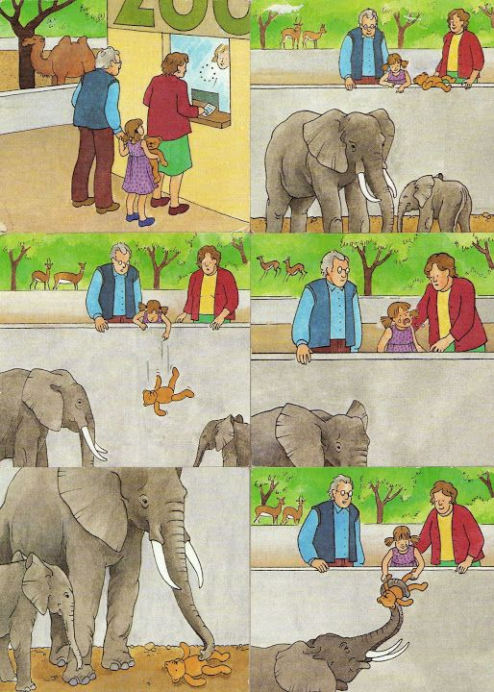
Appendix 2
