HS/TE14/0046 - S.T.A.Wickramasinghe
Lesson Plan - Observation 02
Unit - Unit 8 - It's a Small World
Grade - Grade 08
Time allocated - 40 minutes
Class profile - 15 ESL students (11 male and 4 female) JMC International
College.
Main aims - Extract specific information from the given passage.
. - Transfer the given information in a text to a table.
- Enable the students to identify different feelings,
expressions and emotions.
Subsidiary aims - Recognizing the general idea of a text.
- Enhancing vocabulary.
- Using both context and picture clues to determine the
meaning of new words.
Assumptions - Students will be able to extract specific information from the
passage and transfer the information into a table.
Anticipated problems - Students may have difficulty in determining the meaning of
some words and phrases.
Possible solution -Explaining difficult words, phrases and new vocabulary
given in the text using simple language before starting the
activity.
Materials needed - Two sets of worksheets
A variety of coloured pictures
Bristol board
Pupil's book
Whiteboard
Skills focused - Reading, Writing, Speaking, Listening
Rationale -The purpose of selecting this lesson is to enable the students to
extract the information in a text and transfer the needed
information into other forms.
Procedure -

Time | Stage aim | Teacher role |  |  | Student role |  |  | Materials needed |  | Interaction pattern
Pre Task

10 minutes | To gather information by asking questions. |  | Teacher asks the students to imagine that she is a 13 year old boy called James Smith who came to Sri Lanka in his vacation. Teacher asks the students to get information from James Smith by asking different questions and the teacher answers them pretending to be James Smith and shows pictures of different places pasted on bristol boards. (Appendix 2) |  | Speaking  Students ask different questions from the teacher regarding James Smith's visit to Sri Lanka imagining that the teacher is James Smith. |  |  | A picture of a 13 year old British boy  (Appendix 1) |  | Whole class activity
While Task

20 minutes | To extract information from the given text and to transfer the needed information into a table. |  | Teacher divides the class into 5 groups and distributes a worksheet (Appendix 3) to each group with a table to be filled using the given text (Appendix 4) from Activity 8.8 in the pupil's book. |  |  | Reading,Writing, Speaking  The students discuss with each other and fill the table with necessary information from the text. | Pupil's book  Worksheets  (Appendix 2) |  | Group activity
Post Task

4 minutes | To present the gathered information in front of the class. |  |  | Teacher asks a student from each group to present the gathered information in front of the class and for the other students to listen and tell if there is any other information to be added. The teacher provides feedback. |  | Speaking, Listening, Reading  One student from each group reads the gathered information and the rest of the groups tell if there is anything to be added. |  | Worksheets |  | Group activity
4 minutes | To identify different feelings, expressions and emotions. |  |  | Teacher distributes worksheets  (Appendix 5) that contain a fill in the blanks activity about different feelings and expressions to each student. |  | Reading, Writing  Students will fill in the blanks of the given text. |  | Worksheets  (Appendix 4) |  | Individual activity
2 minutes | To identify different feelings, expressions and emotions. |  |  | Teacher distributes a set of five pictures of expressions and feelings (Appendix 6) related to the previous activity to each group and ask the students to show the picture that matches the correct answer when the teacher discusses answers to the previous fill in the blanks activity. |  | Students will show the picture that matches the correct answer when the teacher discusses the answers from the previous fill in the blanks activity. |  | Sets of coloured pictures |  | Group activity

Take home assignment –
Teacher asks the students to write a short essay on the topic 'My favourite place in Sri Lanka'

Appendix

Appendix 1


Appendix 2
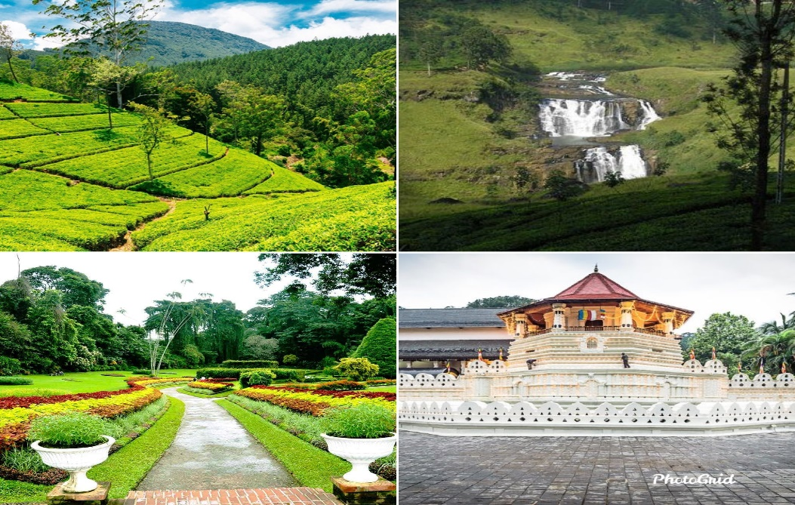
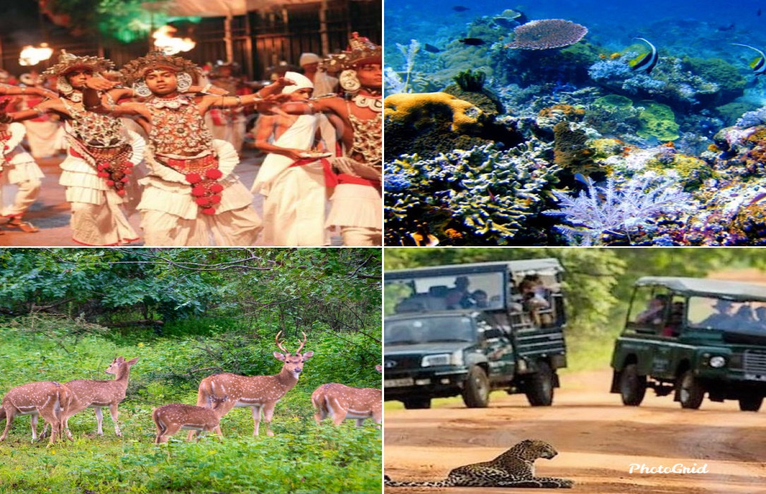

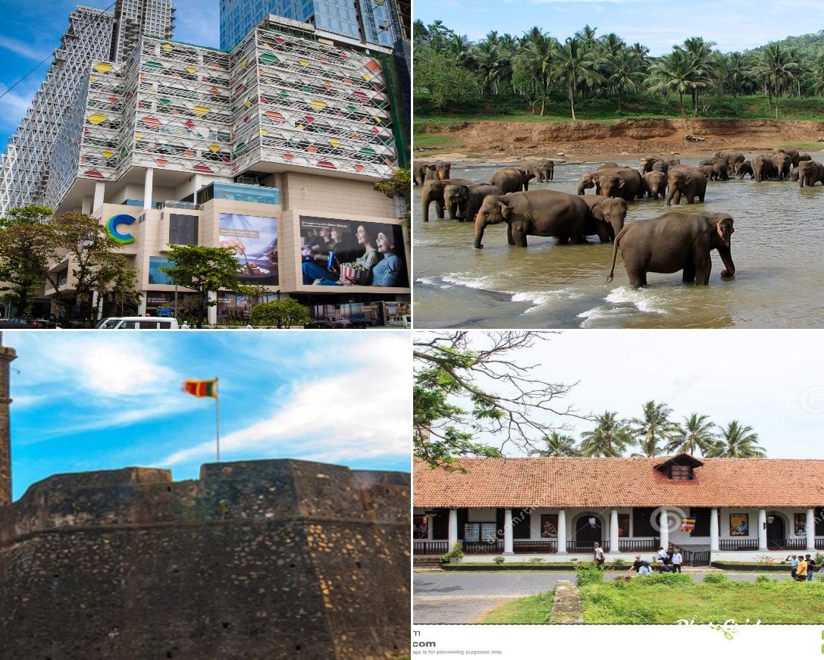

Appendix 3

Date | Places visited | Picture number | What James saw/did | How James felt

Appendix 4
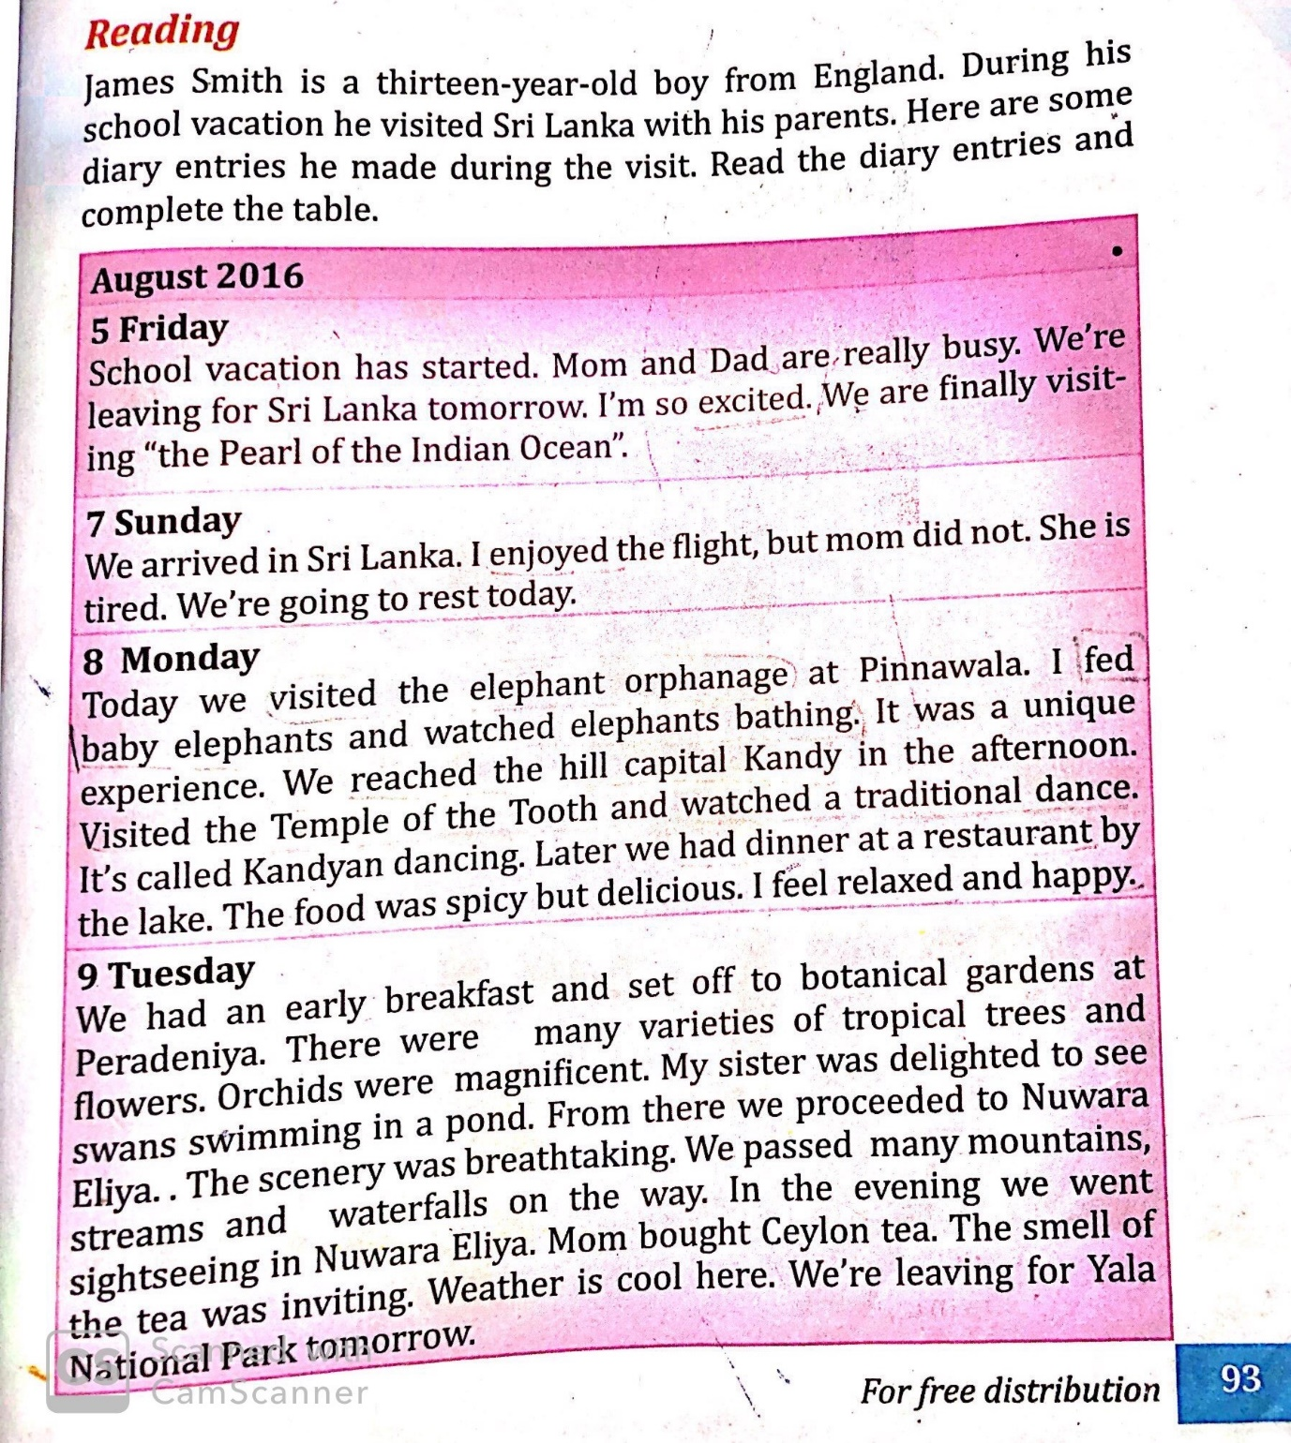

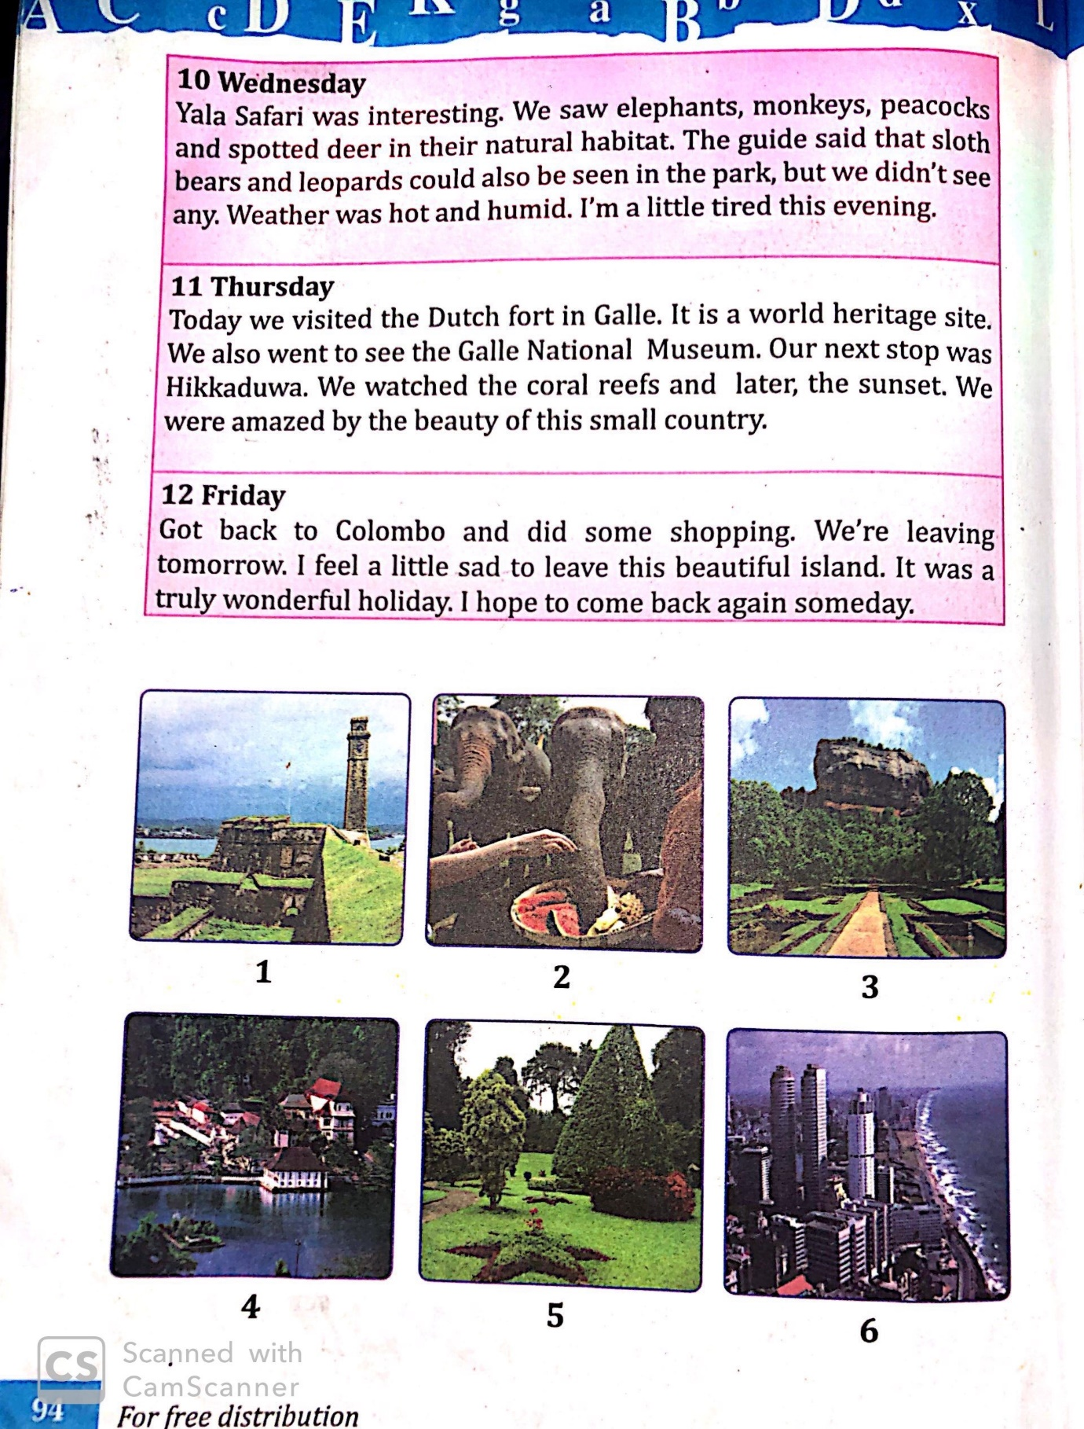

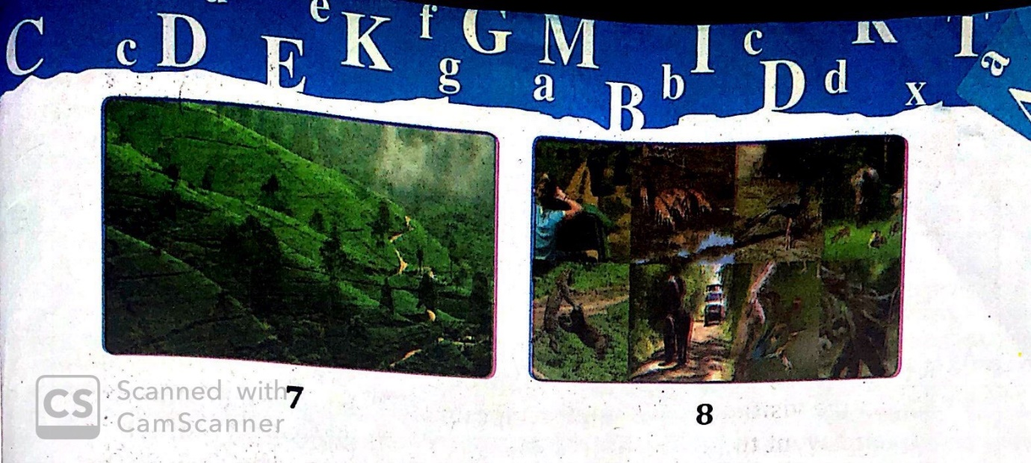

Appendix 5
Fill in the blanks using the appropriate word given in the brackets.
(tired, happy, sad, excited, relaxed)
Jane is a little girl from Canada. She was so ________________ when she saw a puppy in her Christmas gift box. Even though she was ____________ after playing with the puppy the whole day, she felt ________________ every time she hugged the puppy. She enjoyed spending time with the puppy. A few days later the puppy fell sick making Jane so ______________. Luckily the puppy got better in a few days which made Jane really ______________.
Appendix 6
