HS/TE14/0046
S.T.A.Wickramasinghe
Lesson Plan
Unit - Unit 9
The Greatest Wealth
Grade - Grade 09
Time allocated - 40 minutes
Class profile - 16 ESL students (11 male and 5 female) JMC International
College.
Main aims - Help students to identify the tenses of the main clause and the
subordinate clause in conditional sentences. (Types 1and 2)
- To expand grammatical competence of the students.
- Help students to identify the grammatical relations in
conditional sentences.
Subsidiary aims - To identify Subject/ Verb agreement in the main clause and
the subordinate clause.
Assumptions - Students will be able to use conditional clauses appropriately.
Anticipated problems - Students may not know the tenses of the main clause and the
subordinate clause in conditional sentences.
Possible solution - Teaching the tenses of the main clause and subordinate clause
explaining the rules where necessary.
Materials needed - Pupil’s text
Whiteboard
Skills focused - Writing, Reading
Rationale -The purpose of selecting this lesson is to expand grammatical
competence of the students related to conditional sentences.
Procedure

Time | Stage aim | Teacher role |  | Student role |  | Materials needed |  | Interaction pattern
Pre Task

10 minutes | To express sentences using ‘If’ clauses. | Teacher tells some sentences of realistic situations that are likely to happen with the ‘If’ clause and writes them on the board. Teacher asks the students to come up with examples.  . |  | Speaking  Students give examples of sentences with ‘If’ clauses. |  | Whiteboard |  | Whole class activity
While Task

20 minutes | To expand the grammatical competency related to conditional sentences. | Teacher explains the students how to identify the tenses of the main clause and the subordinate clause in conditional sentences (types 1and 2) writing examples on the board as well as to identify the grammatical relations in conditional sentences. Teacher explains Subject/ Verb agreement in the main clause and the subordinate clause writing examples on the board. |  | Listening, Writing  Students listen attentively and take down the points and examples. | Whiteboard |  | Whole class activity
Post Task

10 minutes | Matching the clauses and building meaningful sentences | Teacher asks the students to complete Activity 7 (Appendix 1) in the pupil’s book. | Writing, Reading  Students complete the given activity. |  |  | Exercise book |  | Individual activity

Take home assignment –
Teacher asks the students to complete Activity 6 of the Pupil's book (Appendix 2)

Appendix
Appendix 1
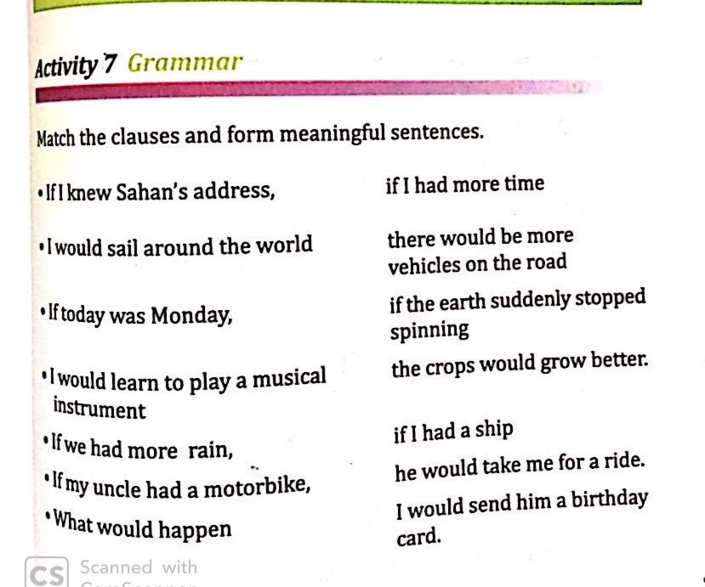
Appendix 2
