HS/TE14/0046
S.T.A.Wickramasinghe
Lesson Plan
Unit - Unit 10
Be Happy, Be Bright, Be You
Grade - Grade 09
Time allocated - 40 minutes
Class profile - 16 ESL students (11 male and 5 female) JMC International
College.
Main aims - Help students to understand poetic language, techniques,
structure and messages given.
- Students will be able to read and respond to simple poems.
- To appreciate the beauty of the language and the thought in
the poem.
. - To kindle the students' imagination and develop students’
aesthetic sense.
Subsidiary aims - To be able to express students’ ideas, feelings, emotions.
- To identify visual, auditory imagery, metaphors and similes,
number of stanzas, rhyming words and themes.
Assumptions - Students will be able to comprehend the poem through
poetic language.
Anticipated problems - Students may have difficulty in understanding poetic
language.
Possible solution -Explaining and discussing the poetic language and meaning
relevant to the poem and writing them on the board.
Materials needed - Pupil's book
Whiteboard
Skills focused - Reading, Writing, Speaking, Listening
Rationale -The purpose of selecting this lesson is to improve students'
imagination and to develop their aesthetic sense.

Procedure

Time | Stage aim | Teacher role |  |  | Student role |  | Materials needed |  | Interaction pattern
Pre Task

10 minutes | To let the students express themselves. |  | Teacher asks the students to express how they feel about themselves. Teacher writes some qualities on the board. |  | Speaking  Students express their ideas and feelings. |  | Whiteboard |  | Whole class activity
While Task

20 minutes | To comprehend the poem through poetic language. |  | Teacher asks the students to recite each stanza poem (Appendix 1) in groups. Teacher asks the students to discuss in groups what they feel about the poem. Teacher explains the visual and auditory imagery, metaphors and similes, number of stanzas, rhyming words and themes of the poem and write them on the board with examples. |  | Speaking, Listening  Students discuss with the group members.  Students write down the poetic techniques and themes with examples. | Pupil’s book |  | Group activity
Post Task

10 minutes | To evaluate if the students have grasped the poem. | Teacher asks the students to complete Activity 16. (Appendix 2) |  | Reading, Writing  Students complete the given activity. |  |  | Exercise book |  | Individual activity

Take home assignment –
Teacher asks the students to build a simple poem about how they feel about themselves.

Appendix
Appendix - 01
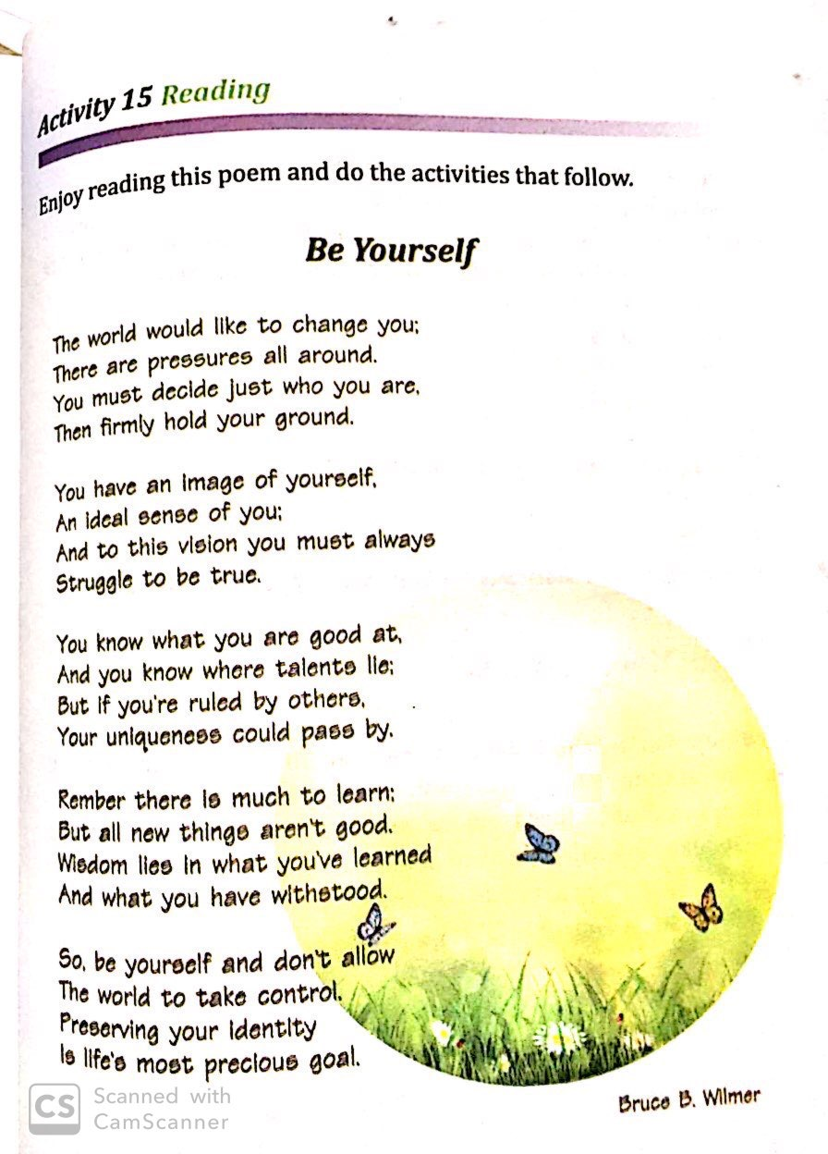
Appendix 2
