HS/TE14/0046 - S.T.A.Wickramasinghe
Lesson Plan
Unit - Unit 12 - Success
Grade - Grade 10
Time allocated - 40 minutes
Class profile - 18 ESL students (12 male and 6 female) JMC International
College.
Main aims - Extract specific information from the given passage.
. - Recognizing the general idea of a text.
Subsidiary aims - Enhancing vocabulary.
- Using linking words and phrases accurately.
- Gather information from the text and complete an essay with
the given guidelines.
Assumptions - Students will be able to extract specific information from the
passage.
Anticipated problems - Students may have difficulty in determining the meaning of
some words and phrases.
Possible solution - Explaining difficult words, phrases and new vocabulary
given in the text using simple language before starting the
activity.
Materials needed - Laptop
A4 sheets
Pupil's book
Whiteboard
Skills focused - Reading, Writing, Speaking
Rationale -The purpose of selecting this lesson is to enable the students to
extract the information in a text and transfer the needed
information into other forms.
Procedure -

Time | Stage aim | Teacher role |  |  | Student role |  |  | Materials needed |  | Interaction pattern
Pre Task

10 minutes | To get the students to express their ideas. |  | Teacher asks the students about the famous comedians they know and shows a 3 minute video clip of Charlie Chaplin. (Appendix 1). Teacher discusses about Charlie Chaplin and his work with the students. |  | Speaking,Listening  Students answer and discusses about the comedians they know and watch the video clip. |  |  | Laptop |  | Whole class activity
While Task

20 minutes | To extract information from the given text |  | Teacher asks the students to read the passage (Appendix 2) together. Teacher explains the highlighted words and the difficult words and phrases. |  |  | Reading, Speaking  The students read the passage and identify highlighted and difficult words and phrases and get the general idea of the text. | Pupil's book |  | Whole class activity
Post Task

10 minutes | To extract information from the given text and to transfer the needed information into an essay. |  |  | Teacher asks the students to complete Activity 08 (Appendix 3) of pupil’s book. |  | Reading,Writing  Students complete the given activity in A4 sheets. |  | A4 sheets |  | Individual activity
 | .

Take home assignment –
Teacher asks the students to complete Activity 09 in the pupil’s book. (Appendix 4)

Appendix - 01
https://www.youtube.com/watch?v=_0a998z_G4g

Appendix 2
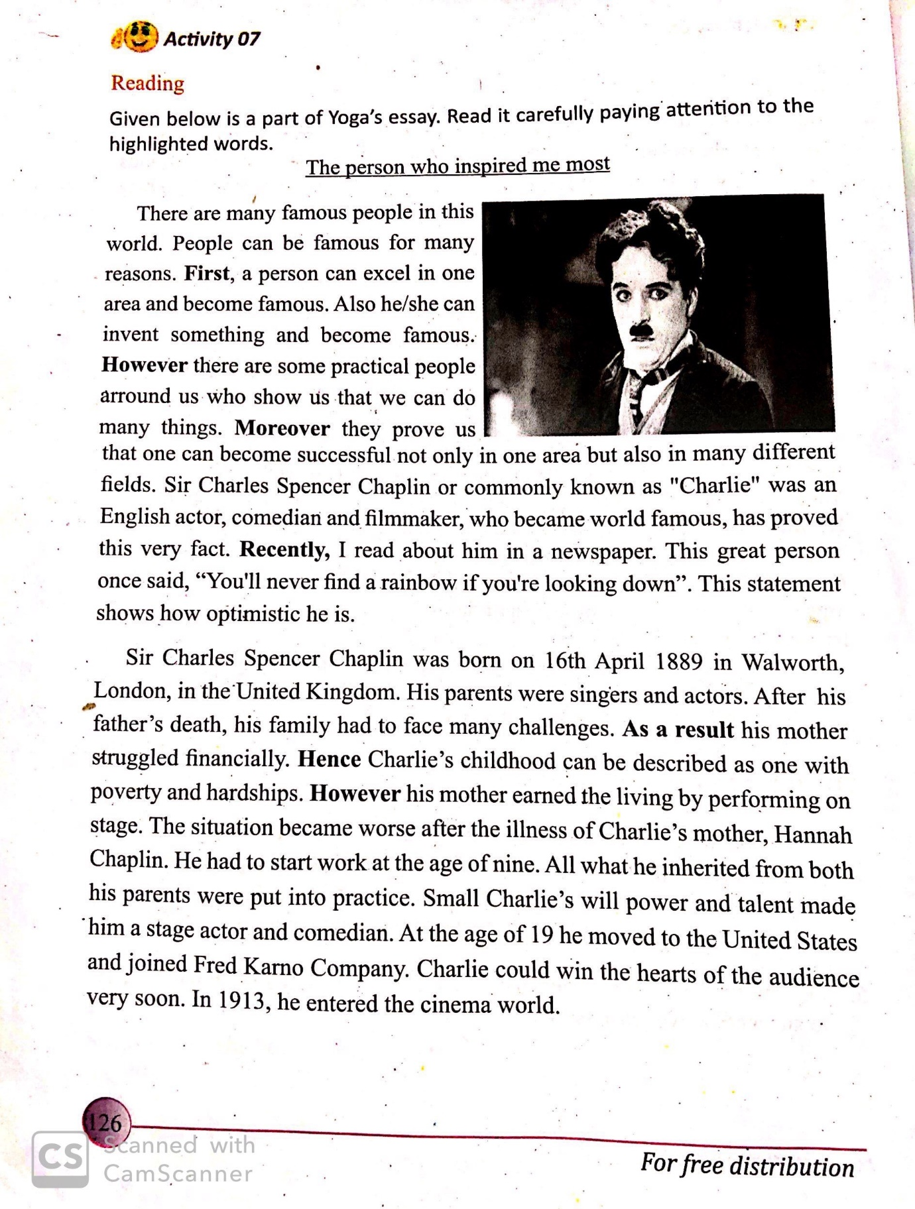

Appendix 3
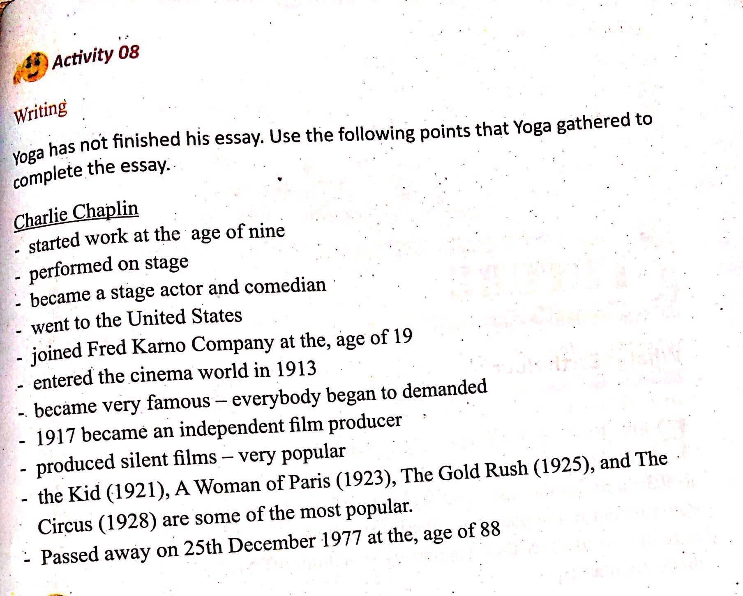

Appendix 4
